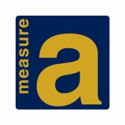**Measure A South Coast Safe Routes to School Program**

**Cycle 6 Sponsorship Agreement**

*A separate sponsorship agreement must be attached to each pre-application requiring a sponsor.*

**Project Information**

Project Title: Click or tap here to enter text.

Project Category:  Capital Project  Plan or Study  Program

Total amount of Measure A funds requested for this project: $

**Implementing Agency Information**

Implementing Agency:Click or tap here to enter text. Contact: Click or tap here to enter text.

Contact Phone:Click or tap here to enter text. Contact Email: Click or tap here to enter text.

Total number of pre-applications being submitted by implementing agency: Click or tap here to enter text.

If submitting more than one pre-application, the priority number of this pre-application is: Click or tap here to enter text.

**Sponsor Information**

Contract Administrative Agency:Click or tap here to enter text. Contact:Click or tap here to enter text.

Contact Phone:Click or tap here to enter text. Contact Email: Click or tap here to enter text.

Signature of Cooperative Agreement Administrator:



Additional Sponsors:  Contact:

**Please submit sponsorship agreement as an attachment to Cycle 6 pre-applications.**